**All Configuration Files**

First Create all the required files for configurations in Visual studio. Files are in screenshot.

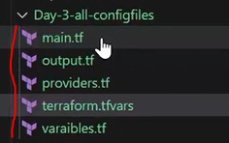

Then go to terminal and configure secrets using aws configure command.

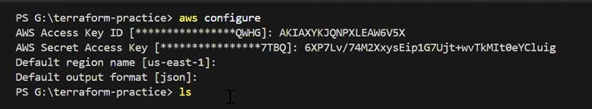

1. **Provider.tf**

Initially if we want than we will provide the provider version. If we will not provide than it will take automatically latest one.

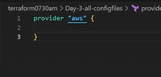

1. **Main.tf**

Create a instance resourse. This file responsible for creating resourses.

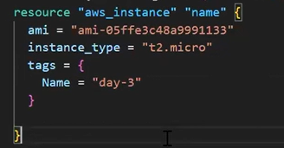

Then execute terraform init then .terraform folder will create. Then when we will run terraform plan it will show shats are changes will perporm if we will execute teffaform apply.

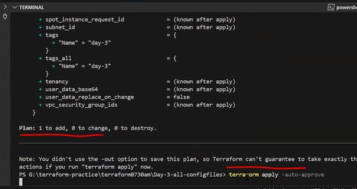

Once terraform apply executed successfully than saw your aws account EC2 created successfully. Log showing as its created successfully.



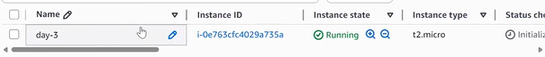

If I want to destroy the resource than command is



If we defined values in Variable.tf file than how we will call in main.tf file.

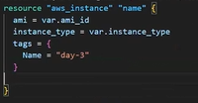

Here we not changes anything in provider.tf. so we will execute only terraform plan . Once its success than move direct values in variable.tf file to terraform.tfvars

1. **Output.tf**

This file acts as to print any values for resourses. Here we are trying to print for EC2 Ip. From main.tf what is the resourse name. based on resourse name we are calling to print. 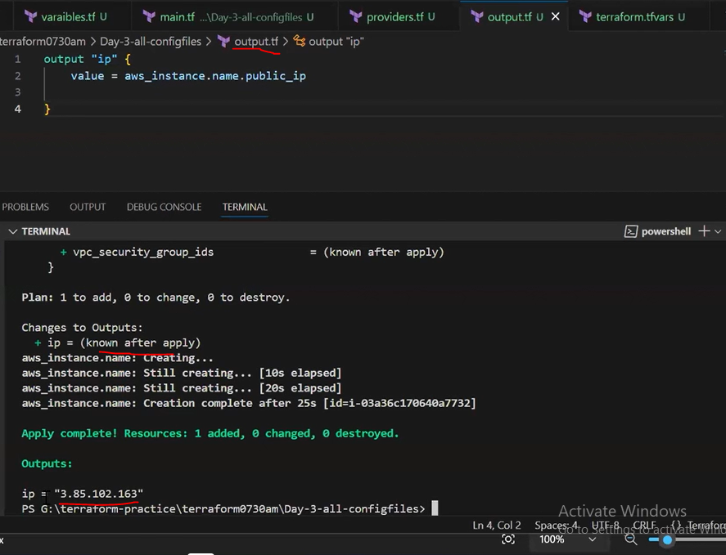

First execute terraform plan if resourse already available in before than than It will show the ip otherwise we need to apply than we can able to see the ip.

If we have 2 servers than which resource name will call this ip will display. We will write like below. 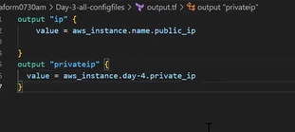

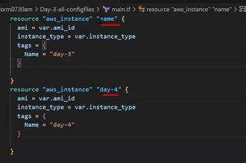

1. **Variables.tf**

What ever values are hard coded in main.tf. That values we will define in variables.tf file and call in main.tf file

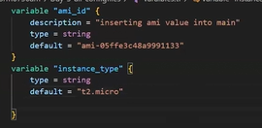

Here we not changes anything in provider.tf. so we will execute only terraform plan . Once its success than move direct values in variable.tf file to terraform.tfvars

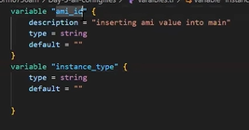

1. **Terraform.tfvars(**This file name can’t change but all other above file name can change**)**

Variable values are defined here. Then execute terraform plan. Once its success than apply

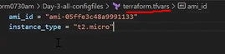

If we have a value defined in variable.tf file default as t2.nano and another value defined also Terrafor.tfvars files as t2.micro than it will override what ever value in terraform.tfvars it will came.

**Focus On TfVars**

Create below files.

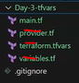

Based on requirement we will create another file. In apply time we can also pass the variable value in command.

1. We will remove the value in tfvars file than run terraform init and plan and apply than it will through error.

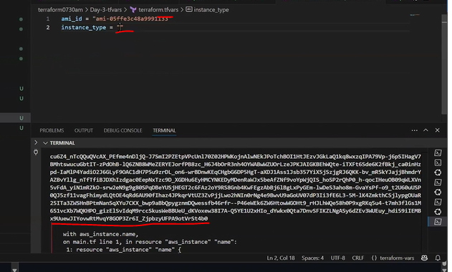

1. Now we removed all the values in terraform.tfvars file and kept in dev.tfvars file.

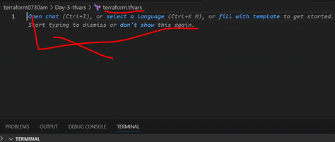

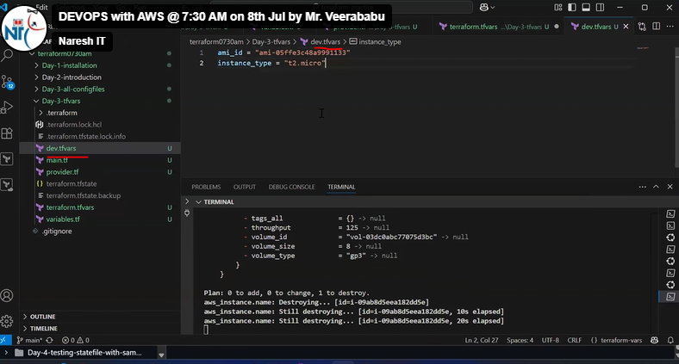

Then remove the terraform.tfvars file and execute the terraform plan than we will see all the attributes are empty. If we will execute the terraform apply than it will throw an error.

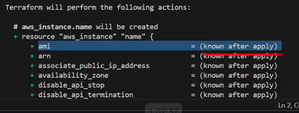



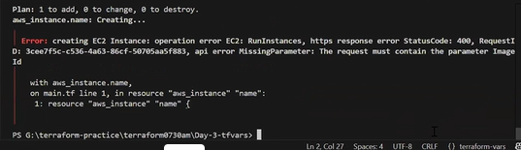

If we will rename from dev.tfvars to terraform.tfvars than it will work.

1. So terraform.tfvar file we can’t changes. If we want to call a different tfvars file than we will execute below command.



1. If we will execute terraform plan than it will call terraform.tfvars. if we want ro call a different tfvars file than we will call in plan command like below.

